Visual Studio 2008 and MSDN 2008 Setup

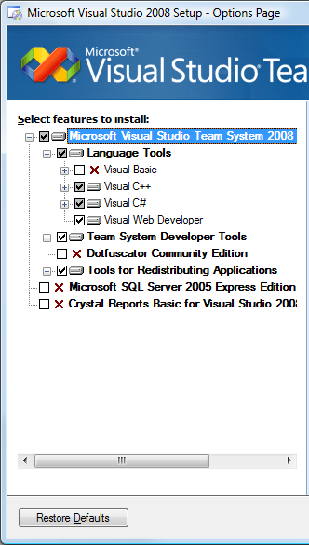
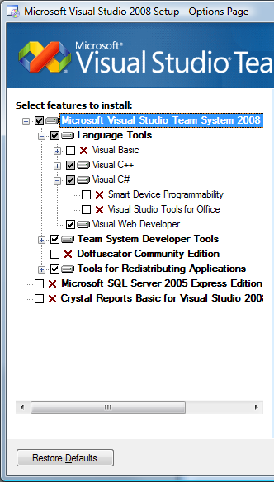
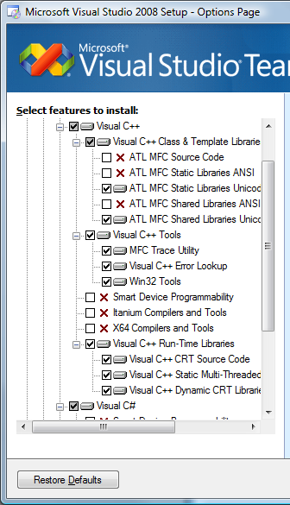

Installation of Visual C++ is not necessary, but I would at least install everything in the subsection called “Visual C++ Run-Time Libraries”.

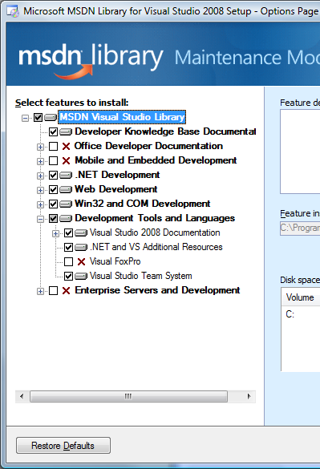

By doing a custom MSDN installation like above, you not only cut down on disk space used, but also reduce the amount of extraneous references / documentation.

